Farm Rescue nonprofit nears another milestone

By BLAKE NICHOLSON, Associated Press

Updated 6:27 am, Friday, August 22, 2014
- 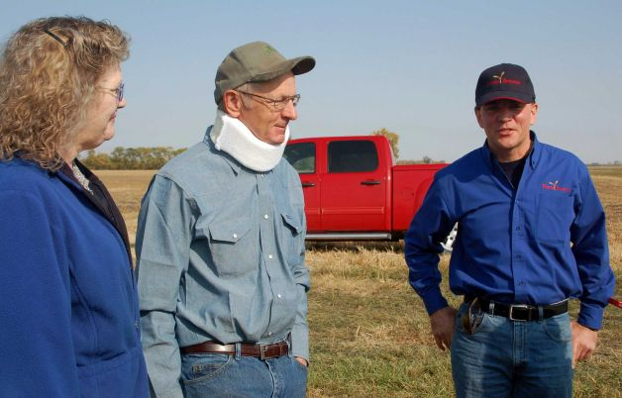
FILE - In this Sept. 27, 2012 file photo, Bill Gross, the founder of Farm Rescue, a nonprofit that helps farmer who are in need, visits with Rose and Dan Dotzenrod, left, at the their farm near Wyndmere, N.D.. The Dotzenrods were the 200th family to receive assistance from the volunteer organization. Dan had broken his neck earlier in the year. Farm Rescue is nearing another milestone. It will help its 300th farm family in the region by the end of the year. Photo: Dave Kolpack, AP

BISMARCK, N.D. (AP) — The Farm Rescue nonprofit in the Upper Midwest is approaching another milestone — it will help its 300th farm family in the region by the end of the year.
The volunteer-based organization headquartered in North Dakota helped its 100th farm family in 2009 and its 200th in 2012.
"Three hundred families in the Upper Midwest are able to continue supporting their communities and feeding America," founder Bill Gross said. "These families are friends, neighbors and customers. They're the rural community."
Farm Rescue plants and harvests crops for farmers in the Dakotas, Minnesota, Iowa and eastern Montana who have experienced an illness, injury or natural disaster. It's been operating since 2006, supported by donations, business sponsors and about 1,000 volunteers.
"I appreciate the work they did for me; it helped quite a bit," said Dan Dotzenrod, who became the 200th farmer to get help after he broke his neck in a fall on his southeastern North Dakota farm. "I'm mostly recovered — 90 to 95 percent. Still farming."
Gross said Farm Rescue, which operates on an annual cash budget of about $450,000, will help about 50 farmers annually for another year or two.
"We need to build more support for the organization financially to expand beyond that level," he said. "We are moving in that direction. Then, if we expand geographically in a few years, that number might grow."
Farm Rescue has gotten a big boost in recent years from The Leona M. and Harry B. Helmsley Charitable Trust, which has contributed nearly $1 million since 2008. Fargo-based RDO Equipment Co., which owns and operates more than 60 dealerships in nine states, has supplied critical equipment, according to Gross.
Keith Kreps, an RDO executive vice president, estimated the company has invested more than $1 million in the partnership.
"Bill approached us with a way to give to the large community that we do business in, and directly affect the farmers and the industry that we make our living in," Kreps said. "We just thought it was the perfect fit."
___
Follow Blake Nicholson on Twitter at: http://twitter.com/NicholsonBlake

